Problem Statement and steps to approach the solution
Activity 1
Issue Statement
- To create a program to input numbers and display them in a list box and display the highest value, low value and the total value
Step to solve the problem
- First we should enter the number to the text box and get them to a list box the following flowchart is used to solve this problem
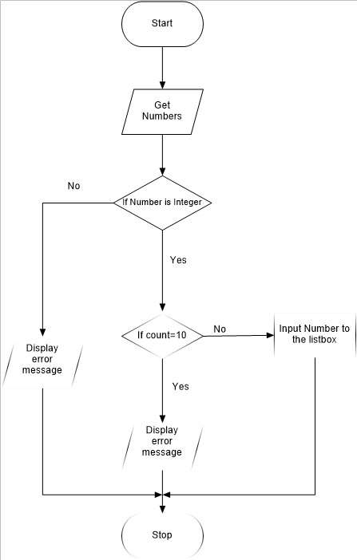

- Then to find the total value for loop can be used

- To find the maximum value while loop can be used the flowchart is given below

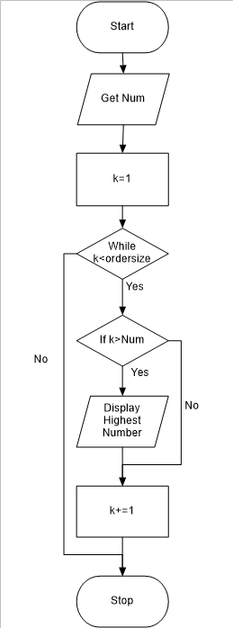

- To find the minimum value while loop can be used the flowchart is given below
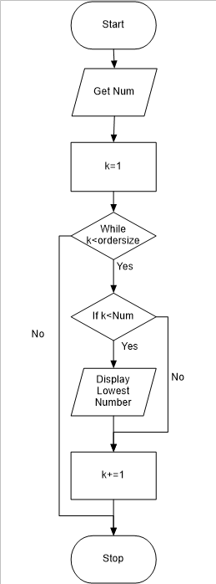

VB.Net code and the commenting for the above mentioned problem
Public Class Form1
Private _numList As Object

Private Property NumList(x As String) As Object
Get
Return _numList
End Get
Set(value As Object)
_numList = value
End Set
End Property

Private Sub btnAdd_Click(sender As Object, e As EventArgs) Handles btnAdd.Click

Dim num As Integer
num = GetNum(num)
'Calling the procedure'

End Sub

Private Sub btnTotal_Click(sender As Object, e As EventArgs) Handles btnTotal.Click
Dim Sum As Integer
For Each row As String In OrderList.Items
Sum = Sum + CInt(row)
Next
'Using for loop to add each number in the listbox'
txtTotal.Text = Sum

End Sub

Private Sub btnHighest_Click(sender As Object, e As EventArgs) Handles btnHighest.Click
Dim k As Integer = 1
Dim ordersize As Integer = OrderList.Items.Count
Dim h_Num As Integer = CInt(OrderList.Items(0))

Do While (k < ordersize)
If (CInt(OrderList.Items(k)) > h_Num) Then
h_Num = CInt(OrderList.Items(k))
End If
k += 1
Loop
'Using while loop to find maximum value from the listbox and display the maximum value'
txtHighest.Text = h_Num.ToString

End Sub

Private Sub btnLow_Click(sender As Object, e As EventArgs) Handles btnLow.Click
Dim k As Integer = 1
Dim ordersize As Integer = OrderList.Items.Count
Dim l_Num As Integer = CInt(OrderList.Items(0))

Do While (k < ordersize)
If (CInt(OrderList.Items(k)) < l_Num) Then
l_Num = CInt(OrderList.Items(k))
End If
k += 1
Loop
'Using while loop to find minimum value from the listbox and display the minimum value'
txtLow.Text = l_Num.ToString

End Sub

Private Sub btnClear_Click(sender As Object, e As EventArgs) Handles btnClear.Click
'Clear the screen for the next entry'
txtHighest.Text = ""
txtInsert.Text = ""
txtLow.Text = ""
txtTotal.Text = ""
OrderList.Items.Clear()

End Sub

Private Sub btnExit_Click(sender As Object, e As EventArgs) Handles btnExit.Click
End
'Exit from the program'
End Sub
Public Function GetNum(ByVal num As Integer) As Integer
'Procedure for displaying numbers in the listbox'
If Integer.TryParse(txtInsert.Text, num) Then
'converts string to integer'
'Here it is used to accept only the integer values'
If OrderList.Items.Count = 10 Then
'checks whether the listbox is filled with its maximum numbers'
MsgBox("10 values are already loaded", vbCritical, "Overloaded")
Else
OrderList.Items.Add(txtInsert.Text)
'Add number to the list box'

End If
Else : MsgBox("Not a number! Only numbers are allowed", vbCritical, "Error")
End If
Return num

End Function
End Class
Screen shots for Activity 1
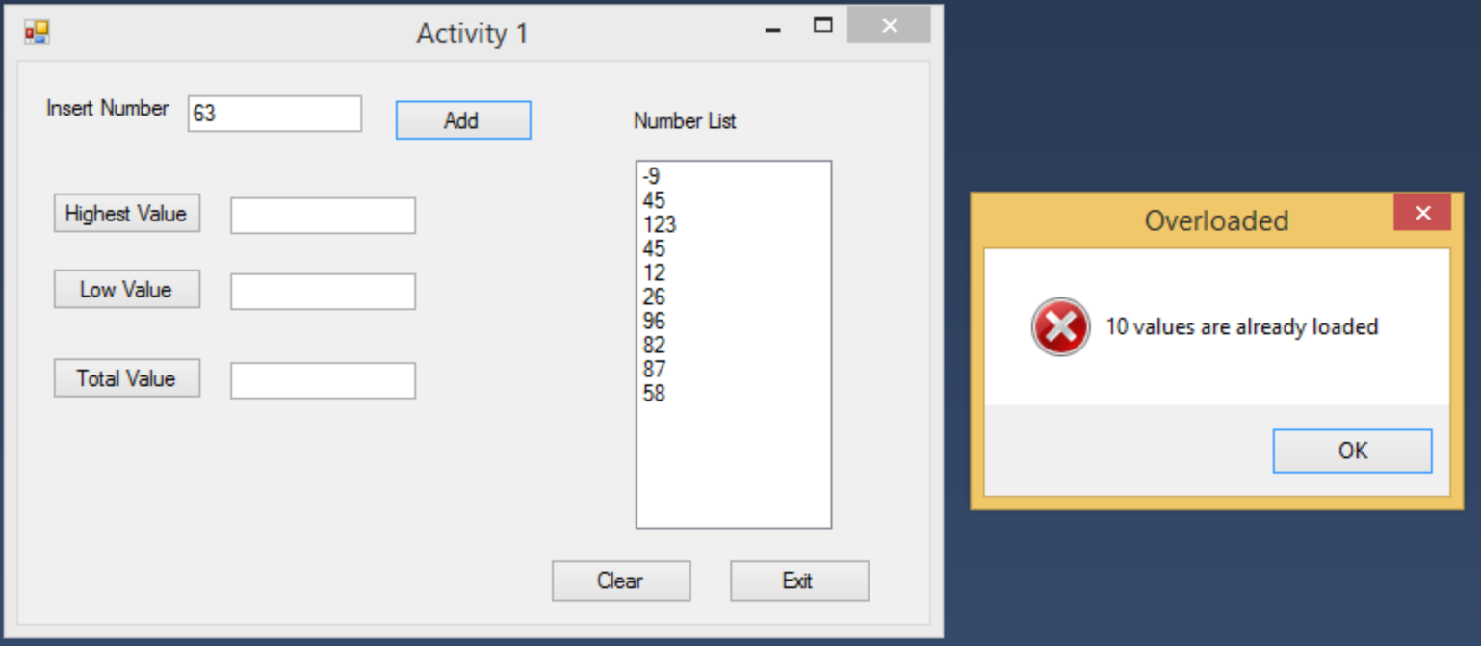
Figure 1 Error message for numbers exceeding 10 entries
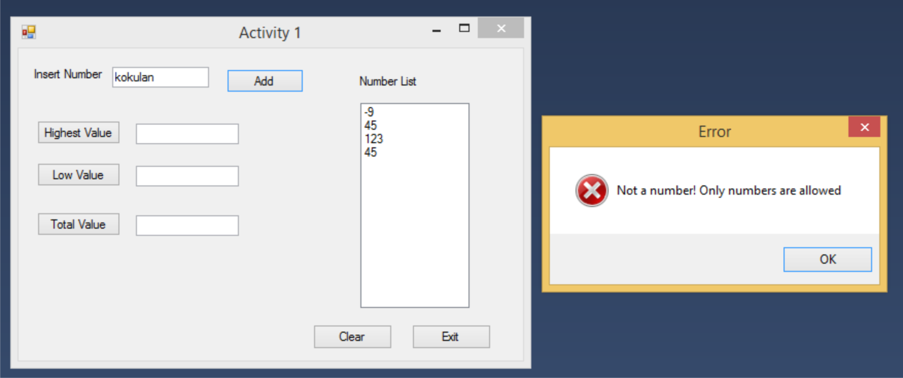
Figure 2 Error message for not inserting an Integer
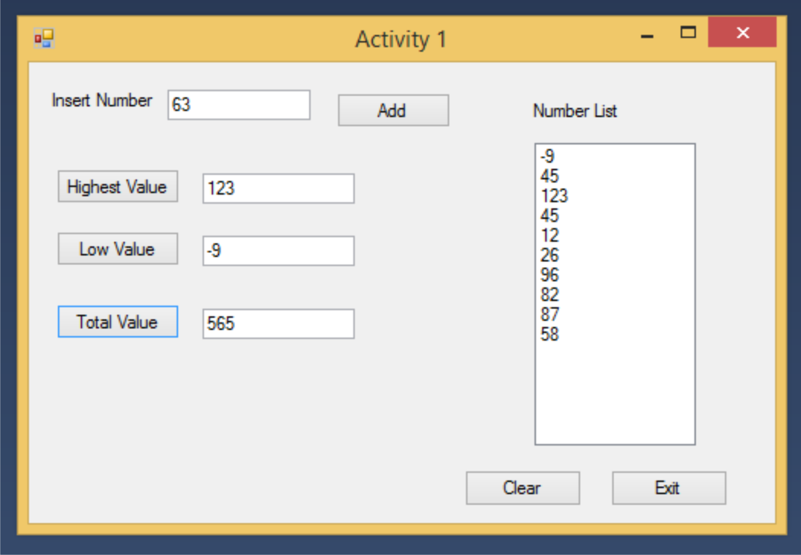
Figure 3 Activity 1 program at a glance
Activity 2
Issue Statement
- To create a program to input numbers and display them in a list box and filter both odd and even numbers and add them to two different list boxes
Step to solve the problem
- First we should enter the number to the text box and get them to a list box the flowchart is same as the flowchart used in Activity 1.
- To sort the odd number if condition can be used and to get the numbers into a separate list box while loop can be used.

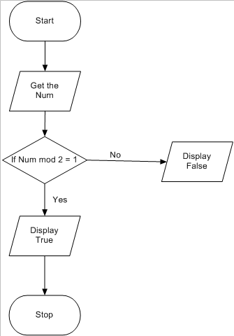

- To sort the Even number if condition can be used and to get the numbers into a separate list box while loop can be used
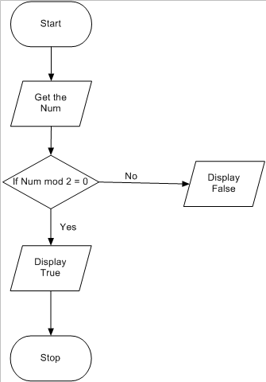

VB.Net code and the commenting for the above mentioned problem
Public Class frmActivity2

Private Sub btnAdd_Click(sender As Object, e As EventArgs) Handles btnAdd.Click
Dim Num As Integer
Num = GetNum(Num)
'Calling the procedure'
End Sub
Public Function GetNum(ByVal num As Integer) As Integer
'Procedure for displaying numbers in the listbox'
If Integer.TryParse(txtInsert.Text, num) Then
'converts string to integer'
'Here it is used to accept only the integer values'

If OrderList.Items.Count = 10 Then
'checks whether the listbox is filled with its maximum numbers'
MsgBox("10 values are already loaded", vbCritical, "Overloaded")
Else
OrderList.Items.Add(txtInsert.Text)
'Add number to the list box'
End If
Else : MsgBox("Not a number! Only numbers are allowed", vbCritical, "Error")
End If
Return num

End Function

Private Sub btnOdd_Click(sender As Object, e As EventArgs) Handles btnOdd.Click
Dim k As Integer = 1
'setting count'
Dim ordersize As Integer = OrderList.Items.Count

Do While (k < ordersize)
'works until the count is less than the count of the number in the listbox'
If o_Num(OrderList.Items.Item(k)) Then
'Calling the procedure and using if condition to add the odd number to the listbox'
OddList.Items.Add(OrderList.Items.Item(k))
End If
k += 1
Loop

End Sub
Private Function o_Num(i_Num As Integer) As Boolean
'procedure for checking the odd number'
If (i_Num Mod 2 = 1) Then
Return True
Else
Return False

End If
'If condition to check the odd number'
End Function

Private Sub btnEven_Click(sender As Object, e As EventArgs) Handles btnEven.Click
Dim k As Integer = 1
'setting count'
Dim ordersize As Integer = OrderList.Items.Count

Do While (k < ordersize)
'works until the count is less than the count of the number in the listbox'
If e_Num(OrderList.Items.Item(k)) Then
'Calling the procedure and using if condition to add the even number to the listbox'
EvenList.Items.Add(OrderList.Items.Item(k))
End If
k += 1
Loop
End Sub
Private Function e_Num(o_Num As Integer) As Boolean
'procedure for checking the even number'
If (o_Num Mod 2 = 0) Then
Return True
Else
Return False

End If
'If condition to check the even number'
End Function
End Class

Screen shots for Activity 2
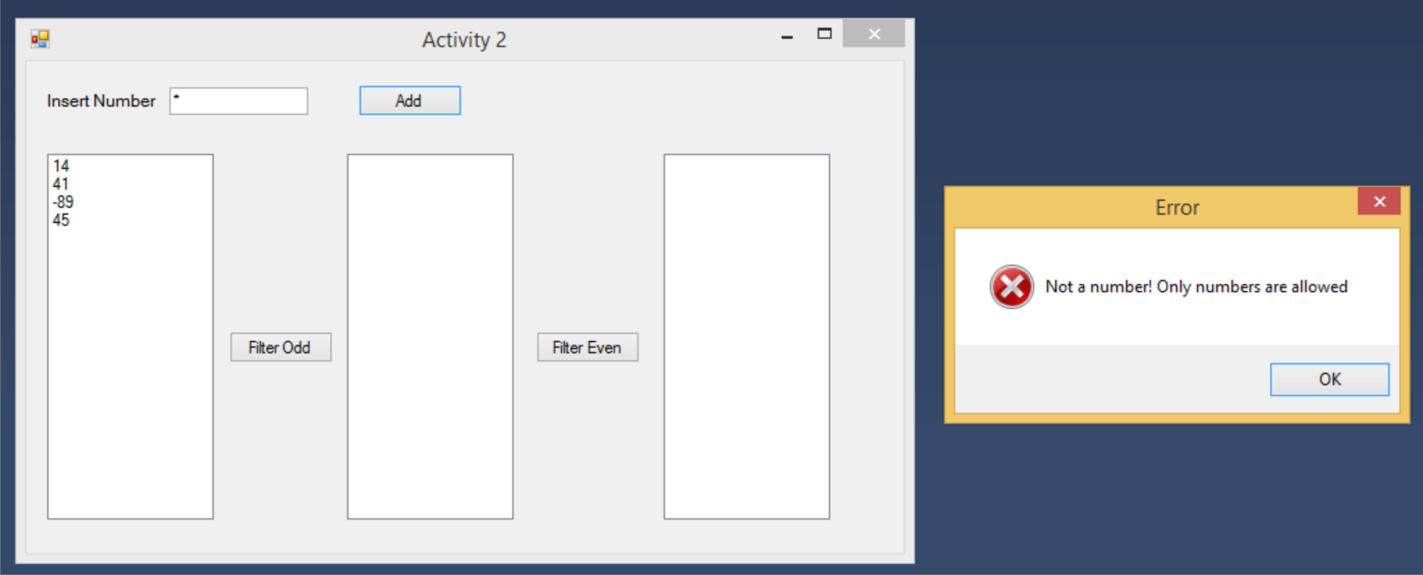
Figure 4 error message for not inserting an integer
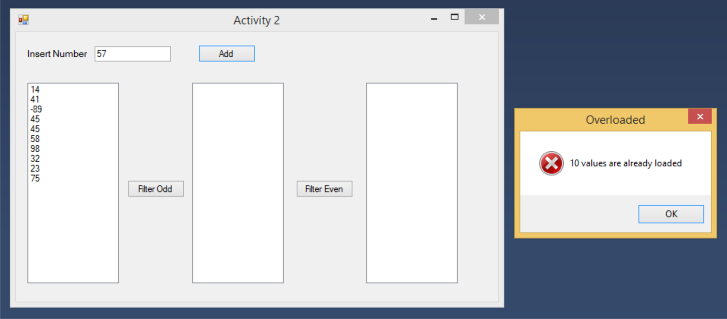
Figure 5Error message for numbers exceeding the limit
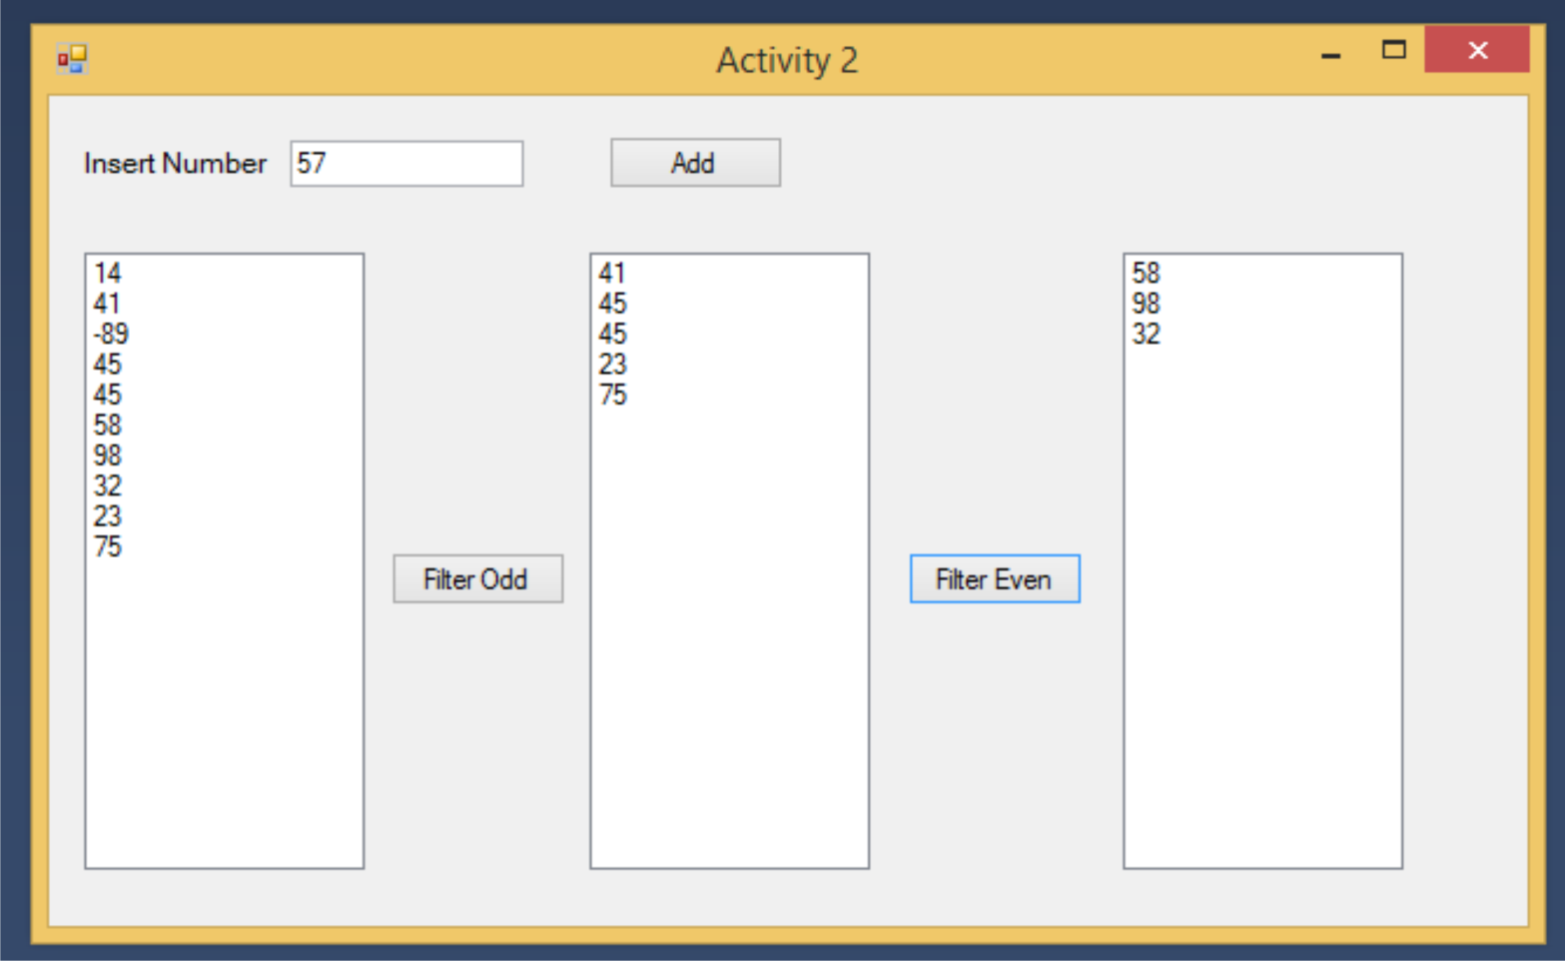
Figure 6 Overall View of Activity 2

